DC-DC boost converter
Circuit Description:
The input and output voltages for the boost converter were fixed as 1V and 5V respectively. Our power output was fixed at 1 W. Since we have used an Arduino PWM output for gating the MOSFET gate, the switching frequency was 20 kHz, thus Ts= 0.05 ms . The switch used in the circuit was 2N660 N-channel enhancement mode MOS transistor.
According to the design constraints the maximum output current was calculated to be Io max=0.2 A .Assuming the capacitance value as very large, we took C=0.8 nF.
The maximum value of the inductor L can be calculated as 100 µH.
Control Strategy:
Our aim was to keep the output voltage of our boost converter constant. We used a simple P controller to achieve this. The output voltage of the converter can be controlled by the PWM signal given to the gate. As explained, the duty cycle of this signal influences Vout. The duty cycle can in turn be controlled by a PID controller. In the controller, the output voltage across the load is given as feedback and compared with a set point. The error is then multiplied with the proportional gain and given as analog input for PWM. We took advantage of the fact that the Arduino Board can give direct PWM outputs; hence we could avoid the use of separate PWM generators. Since at zero error, the PWM should have 0.8 duty cycle (as per calculations), this offset was added to the controller output.
The analog input pin of the UNO board can have a maximum value of 5V. To be on a safer side we limited our input values within 5V. This meant that Vout could not be fed back to the controller directly. That is why we used an attenuator circuit, a π-network of three 1kΩ resistors which gives a feedback voltage proportional to output voltage but within the range. At 5 V the feedback voltage was 5V hence we choose our set point to be 5V. We chose the gain parameter of our controller to be 100.
Problem:
I cannot find 5V in my output
I face problems in choosing the component of circuit.
Please:
I need the code program to control my output of the converter as 5V
If it requires regulators like PID you can added it to the code
I want you to show me the value of input and output of voltage of the converter in the LCD screen (in the same code of controlling program)
I use Arduino 1.6.1 to write codes (c language)
I am using Proteus 8 professional for simulation.

Here is the circuit: (not complete) because you can add best regulators needed to it:
Here is the circuit:
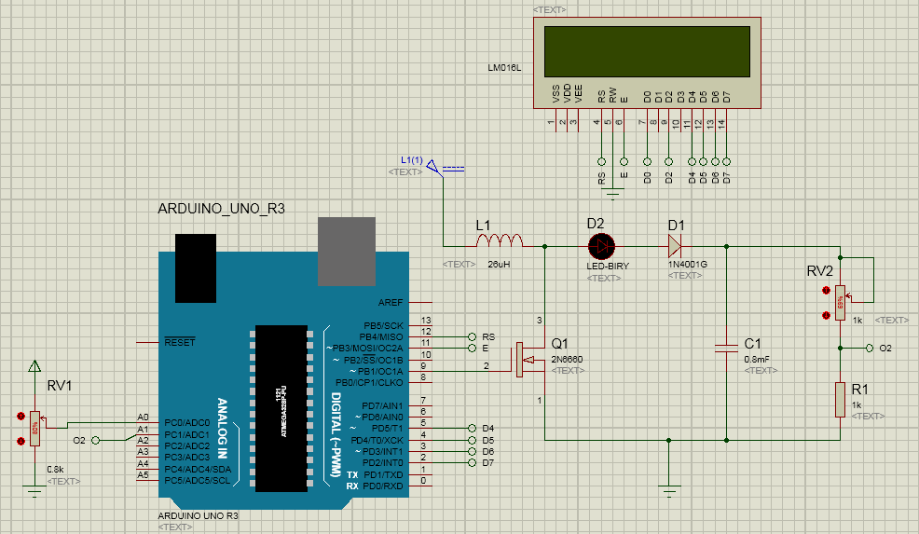

Thank you

