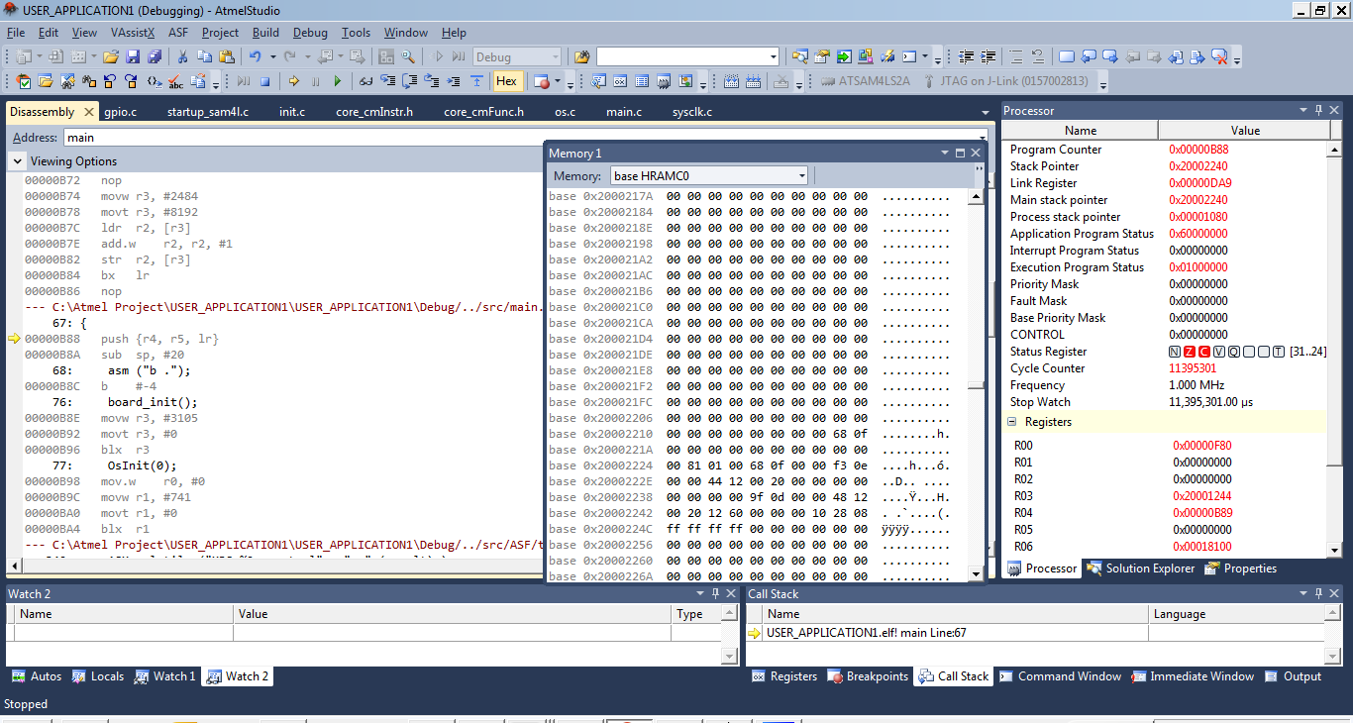

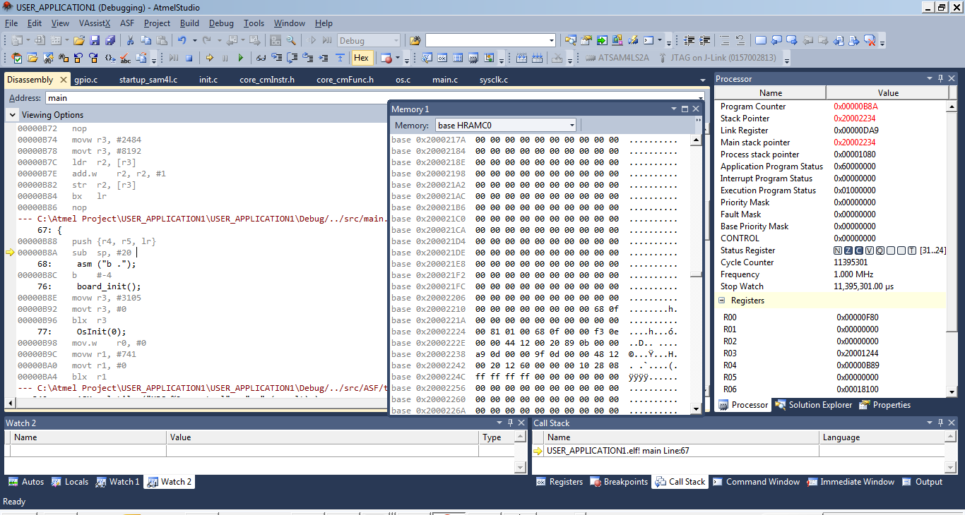

Hi,
I am using ATSAM4LS2A and the GCC compiler with the Atmel Studio 6.1. The GCC generates Prologue for the C function with push instruction to save the registers at the entry. I have been struggling debugging and found that the push instruction of ATSAMLS2A does not seem to save the registers correctly into the stack (and pop fails when function return). I have attached the screen captures to illustrate the problem. The first screen is before stepping through the push instruction. The second screen is after stepping through the push instruction. As you can see, the LR register is not saved correctly in to the stack address (0x2000223C) after stepping. Instead, it is saved in 0x20002238 which is wrong. If I try to use asm("STMDB sp!, {r4, r5, lr}") to do testing, and it works perfectly. I will be very surprised if the push instruction does not works with the chip. Is there something wrong with my hardware to make the chip unhappy? Please help!

